EXPT NO:3 | Designing Multivariate Patterns
DATE: 12.01.2026 | Designing Multivariate Patterns

PRE-LAB QUESTIONS:

- Why is multivariate analysis essential in real-world AI problems?
Real-world problems involve multiple interacting variables; multivariate analysis captures complex relationships that single-variable analysis cannot.
- What challenges arise when visualizing high-dimensional data?
Overplotting, clutter, difficulty interpreting patterns, and limitations of 2D/3D displays.
- How does correlation analysis support feature selection?
It identifies redundant or strongly related features, helping remove unnecessary variables and improve model efficiency.
- What are ethical concerns in healthcare data visualization?
Patient privacy, data misinterpretation, bias reinforcement, and misleading visual conclusions.
- Give examples of multivariate data in AI systems.
Patient health records, credit risk datasets, sensor data in autonomous vehicles, and customer behavior data.

IN-LAB EXERCISE:
OBJECTIVE:
To discover relationships among multiple variables using multivariate visualization.
SCENARIO:
A hospital analytics team studies patient health records to identify relationships between age, BMI, glucose levels, and blood pressure for early disease prediction.
IN-LAB TASKS (Using R Language)
- Generate scatter plot matrix
- Apply color encoding for age groups
- Identify correlated health indicators

CODE:

#23BAD122
#Thiruvarasu.P
X3_healthcare_data
health_data$AgeGroup <- cut(
health_data$Age,
breaks = c(0, 30, 50, 100),
labels = c("Young", "Middle-aged", "Senior")
)
pairs(
X3_healthcare_data[, c("BMI", "Glucose_Level", "Blood_Pressure")],
main = "Scatter Plot Matrix of Health Indicators"
)
colors <- c("blue", "green", "red")
pairs(
X3_healthcare_data[, c("BMI", "Glucose_Level", "Blood_Pressure")],
col = colors[X3_healthcare_data$AgeGroup],
pch = 19,
main = "Scatter Plot Matrix Colored by Age Group"
)
X3_healthcare_data$AgeGroup <- factor(
X3_healthcare_data$AgeGroup,
levels = c("Young", "Middle-aged", "Senior")
)
colors <- c(
"Young" = "blue",
"Middle-aged" = "green",
"Senior" = "red"
)
# Step 4: Add legend
legend(
"topright",
legend = names(colors),
col = colors,
pch = 19,
title = "Age Group"
)
cor(
X3_healthcare_data[, c("BMI", "Glucose_Level", "Blood_Pressure")],
use = "complete.obs"
)

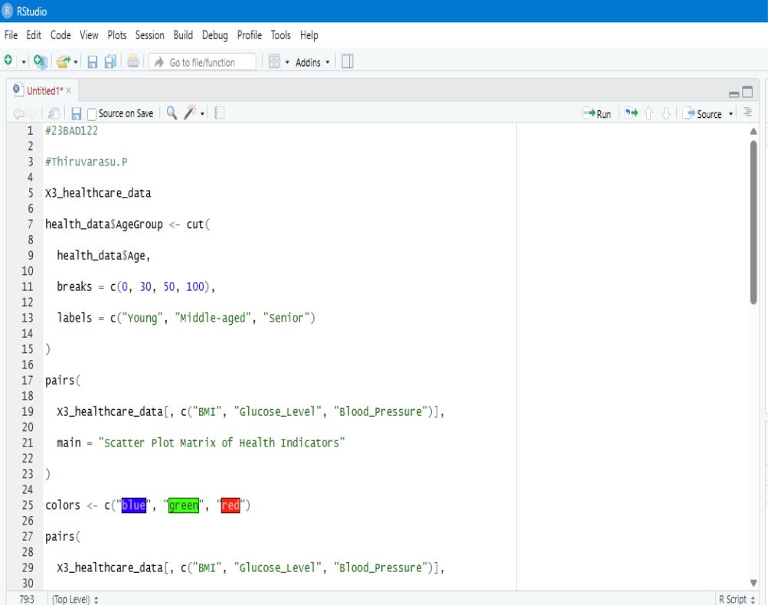

OUTPUT:

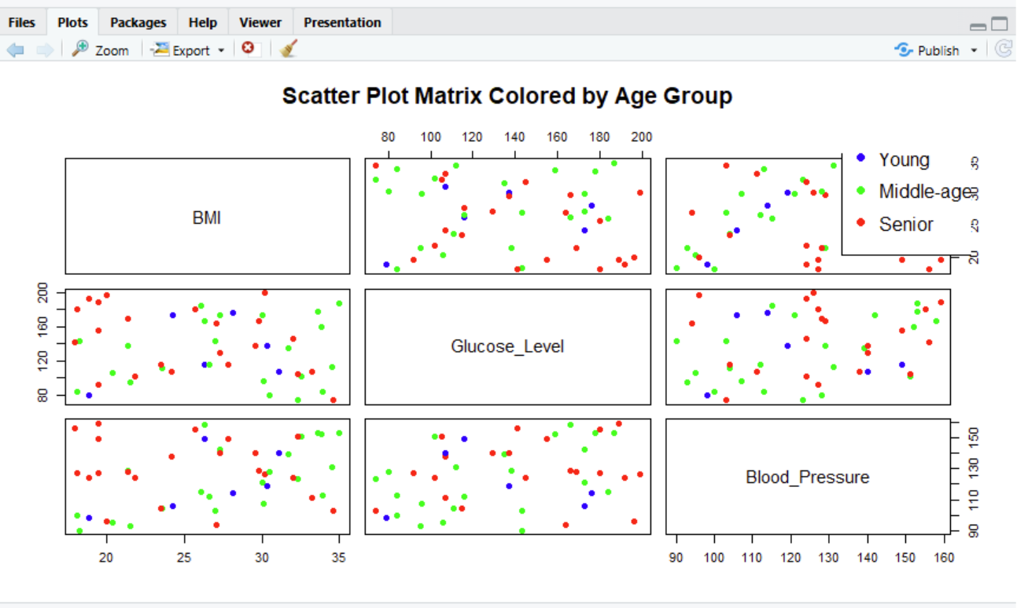

POST-LAB QUESTIONS (PROVIDE BRIEF ANSWERS TO THE FOLLOWING QUESTIONS)

1. Which health parameters show strong correlation?
In the dataset, BMI and Blood Pressure show a strong positive correlation, meaning higher BMI is often associated with higher blood pressure.
Age and Glucose Level also show a moderate positive correlation.

2. Why correlation does not imply causation in medical data?
Correlation only shows that two variables move together, but it does not prove that one causes the other.
Medical data can have confounding factors (like lifestyle, genetics, medication), so the relationship may be indirect or due to other hidden variables.

3. How can these patterns assist predictive healthcare AI?
AI models can use these correlations to:
- Select important features
- Improve prediction accuracy
- Identify risk patterns early
For example, high BMI and blood pressure together may indicate increased risk of heart disease.
4. What visualization limitations exist for high-dimensional data?
- Too many variables create clutter and overplotting
- Hard to interpret in 2D or 3D
- Relationships between many features become difficult to understand visually

5. How can dimensionality reduction improve visualization?
Dimensionality reduction methods like PCA or t-SNE reduce many variables into 2 or 3 key components, preserving most information and making it easier to visualize patterns and clusters.

ASSESSMENT
Description | Max Marks | Marks Awarded
Pre Lab Exercise | 5
In Lab Exercise | 10
Post Lab Exercise | 5
Viva | 10
Total | 30
Faculty Signature

